**Phase1**

**Report**

**Web development Fundamentals**

**CMPS 350**

**Spring 24**

**L02**

**Dr. Mucahid Kutlu**

**Phase 2**

**Group name**: Phonable

**Group members:**

**Mohammed Albazeli 202006253**

**Salman Mohammed 201909507**

**Abdullah Abdullah 201905315**

**Phonable website**



GitHub link: https://github.com/Salman-st1909507/CMPS350-Project-Phase2

Phonable: It is a website for buying and selling mobile phones.

Application design: The design documentation provides a comprehensive overview of the Customer and Seller entities within the web application by know their attributes and functionalities. Our website has 5 interfaces

1. Login

­­­­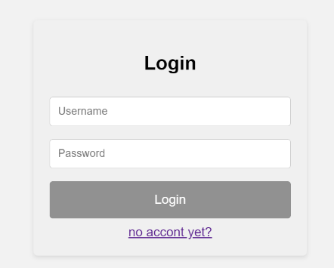

2. Account. An account for the customer and an account for the seller

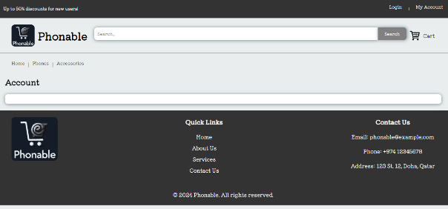

3. Home page

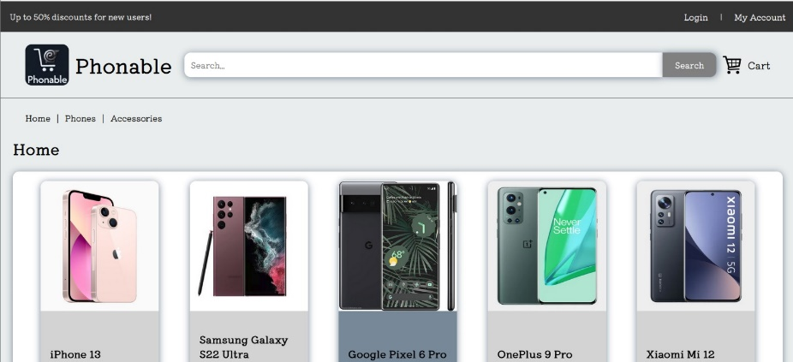

4. Cart

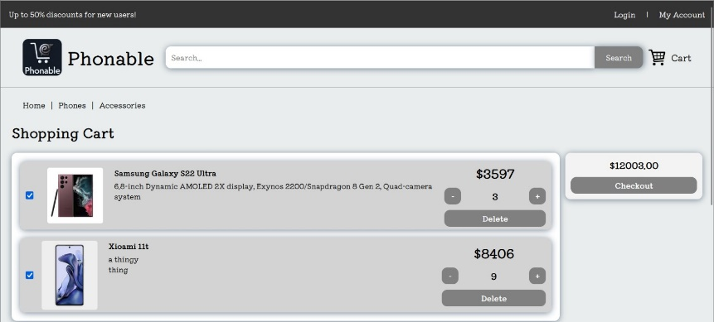

5. Item details

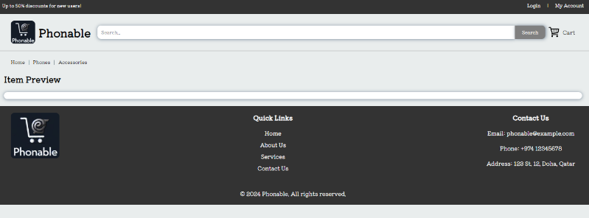

6. Upload an Item

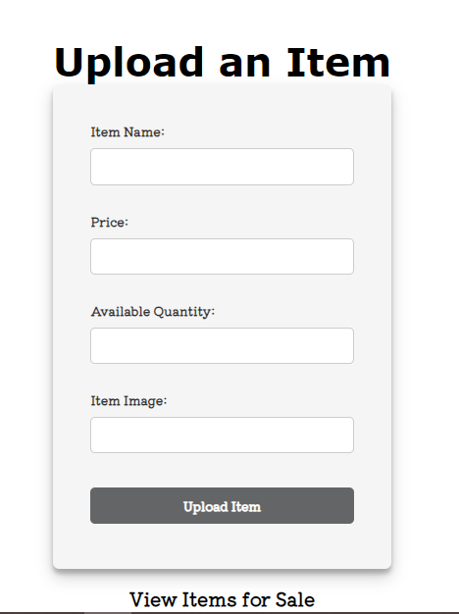

We use a local storage instead of web API

Class Diagram:

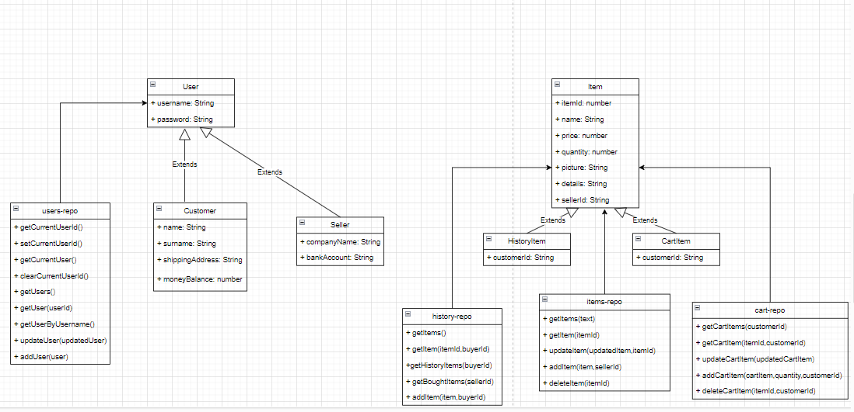

• The platform has the following use-cases:

1. Login

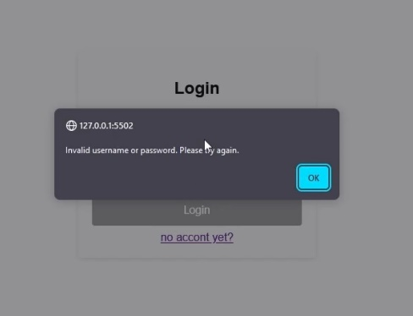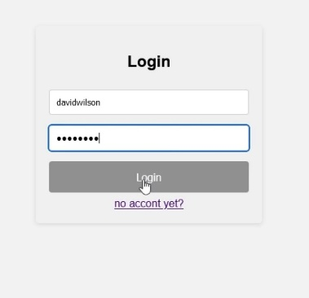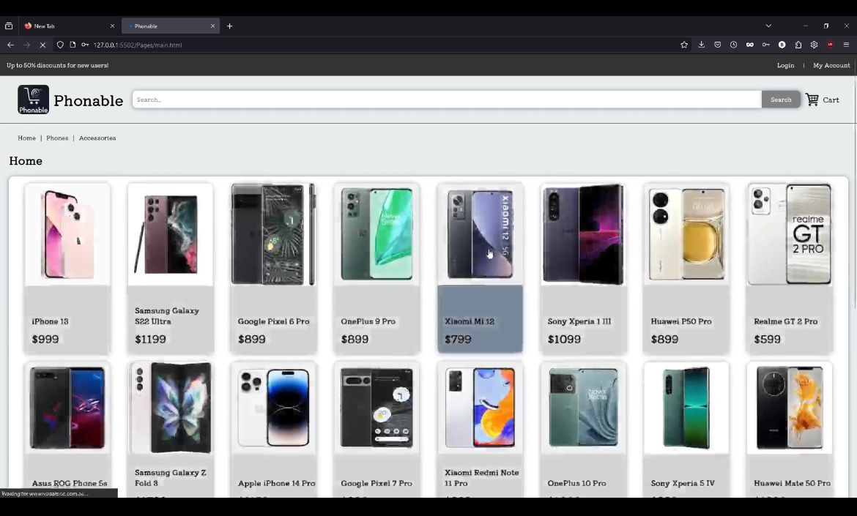

1. Search available items

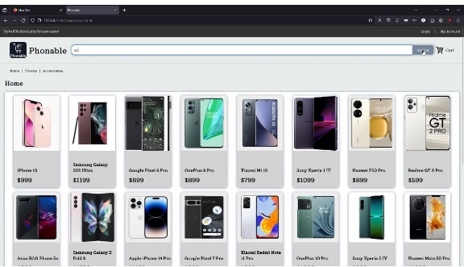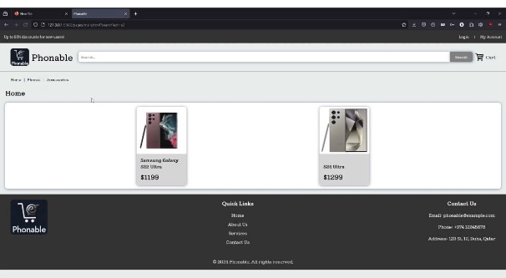

1. Purchase an item

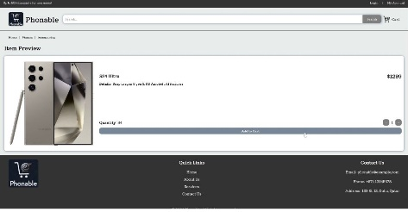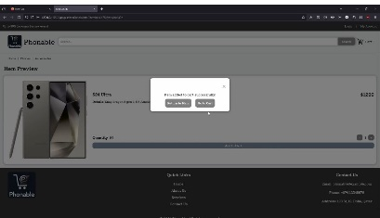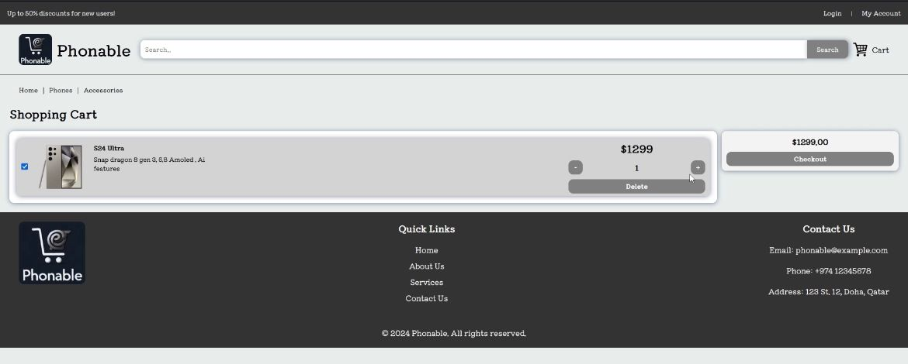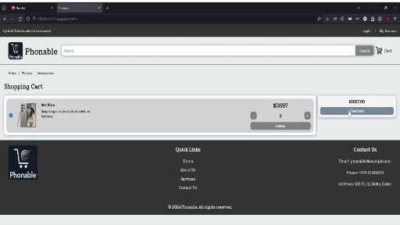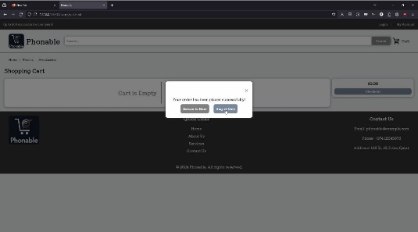

1. View the purchase history

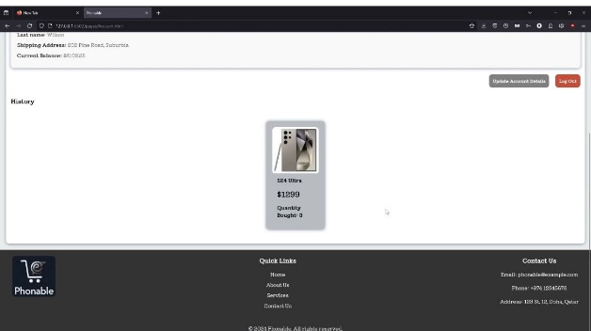

1. View available items on sale and sale history

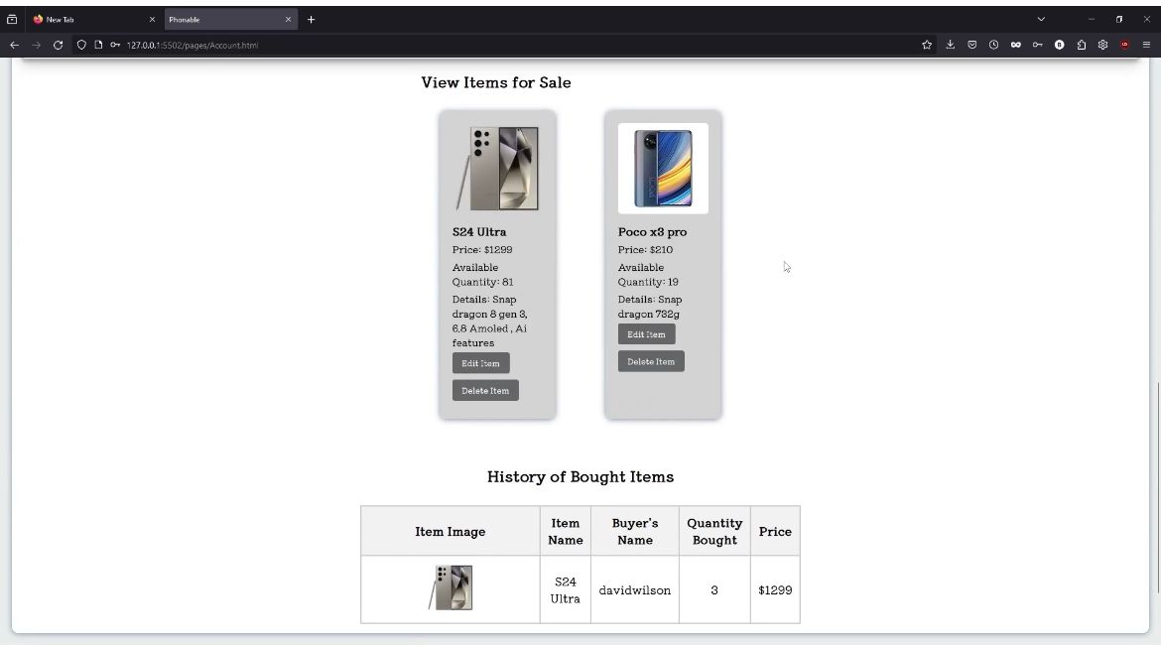

1. Upload an item to be sold

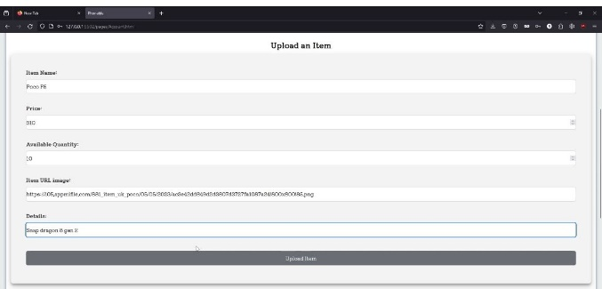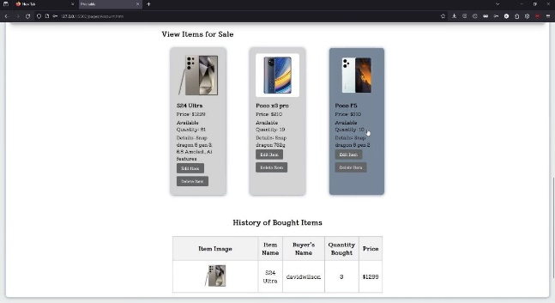

**Phase 2**

**In phase 2 , we used prisma database instead of using LocalStorage. This Is our Model visualization :  
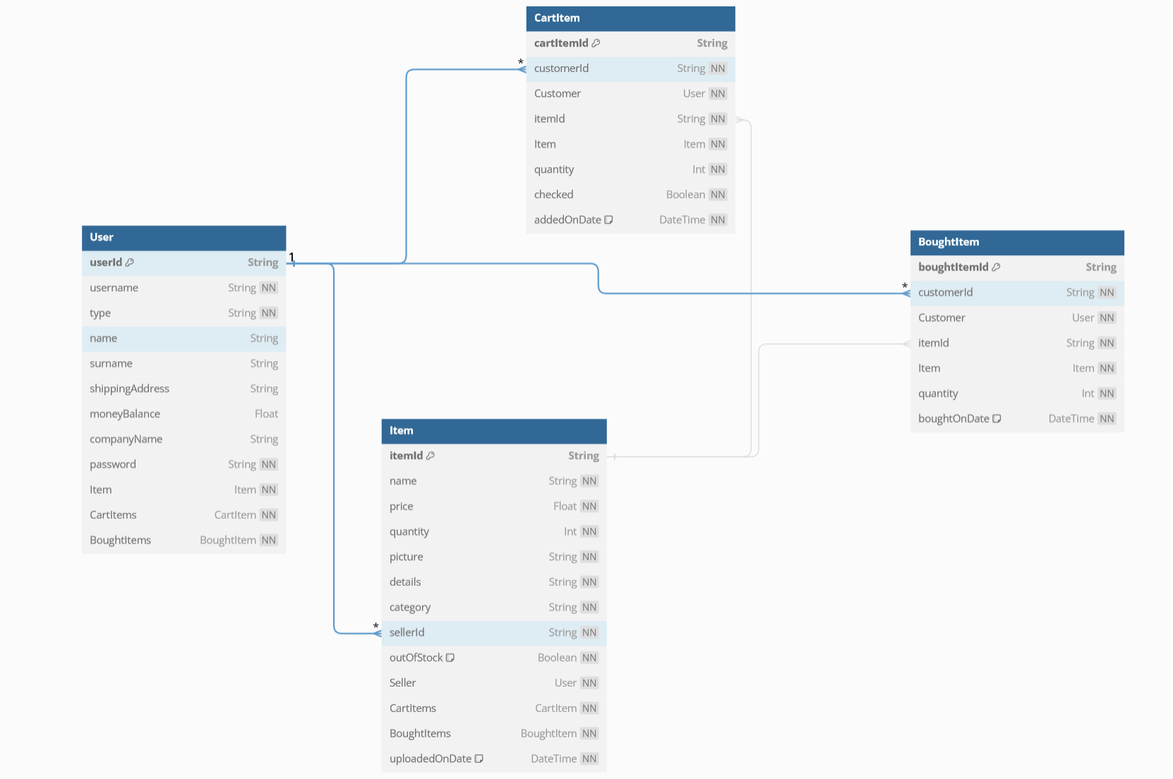**

**Prisma Studio :  
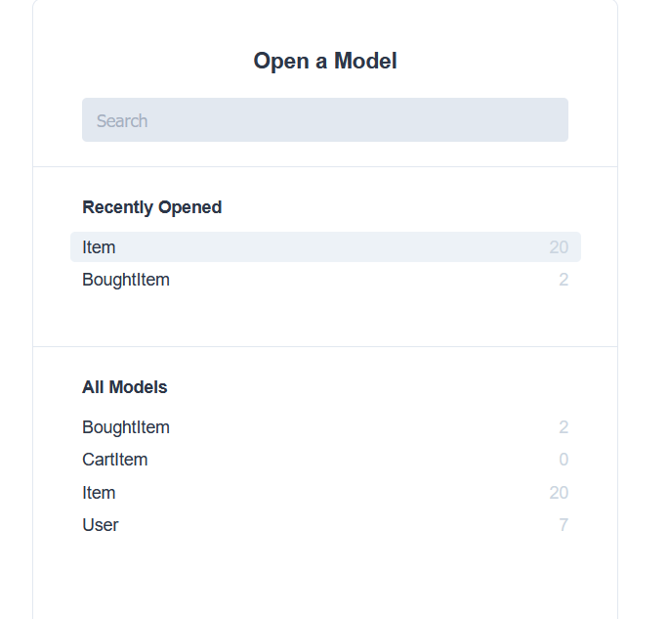**

**Tables/Models:**

**Users;  
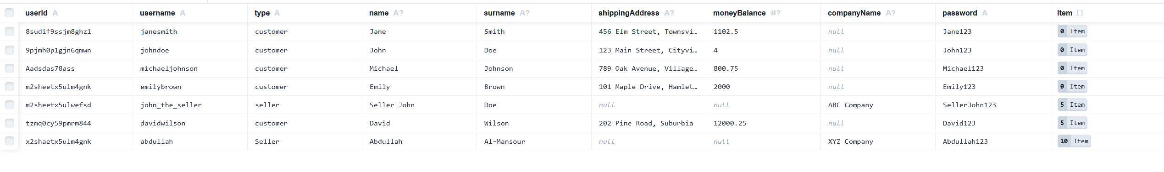**

**BoughtItems:  
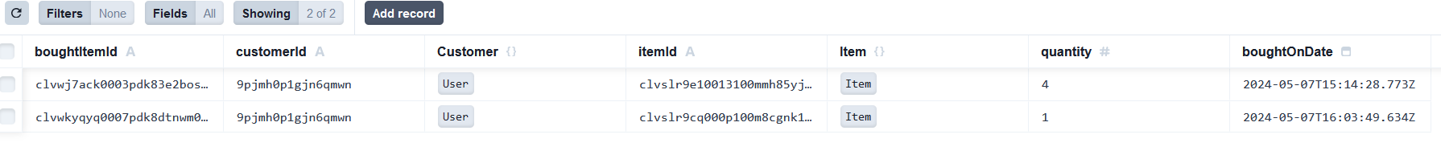**

**Items:  
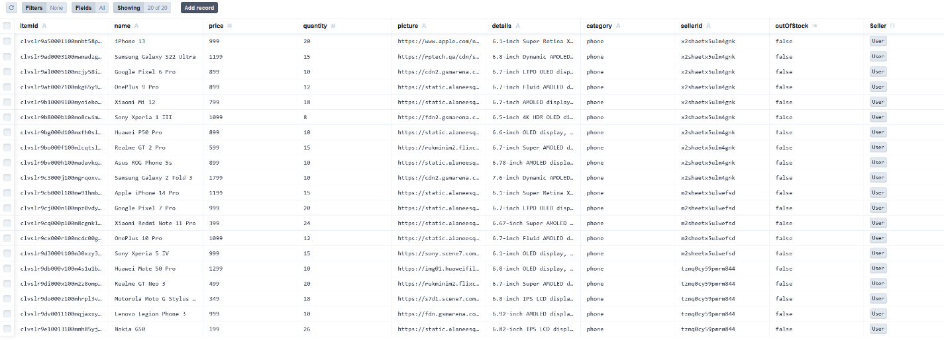**

**Cart Items: Currently Empty since no operations have been done**

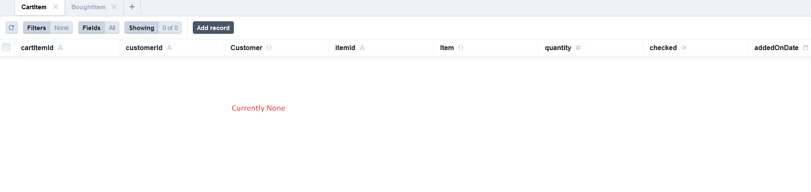

**Database Queries Examples From Repos:**

**Users Repo Snippet:**

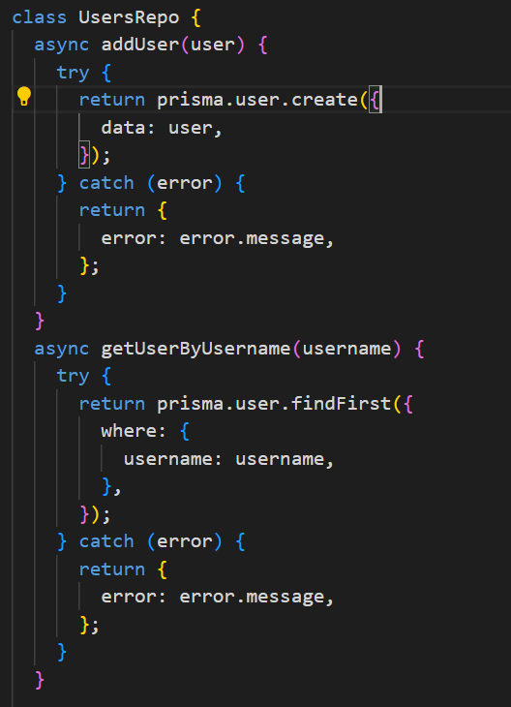

**ItemsRepo Snippet:  
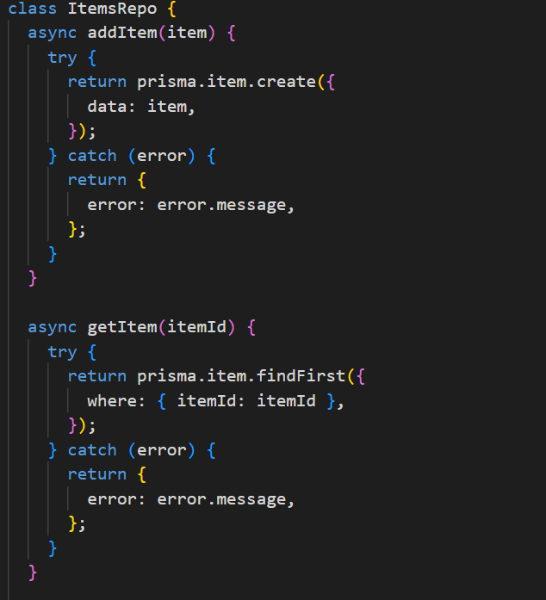**

**BoughtItems Repo Snippet:  
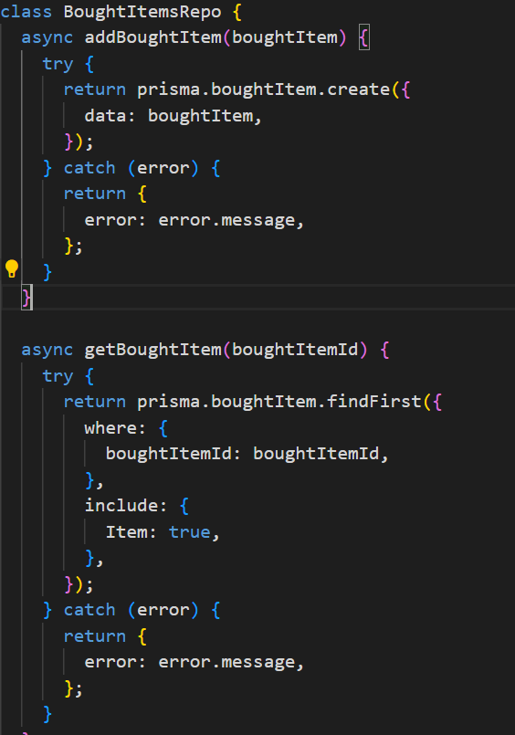**

**CartItems Repo Snippet:  
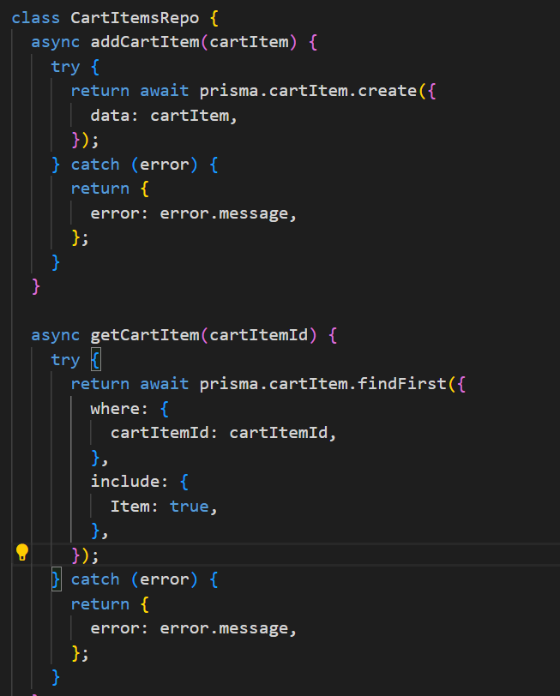**

**  
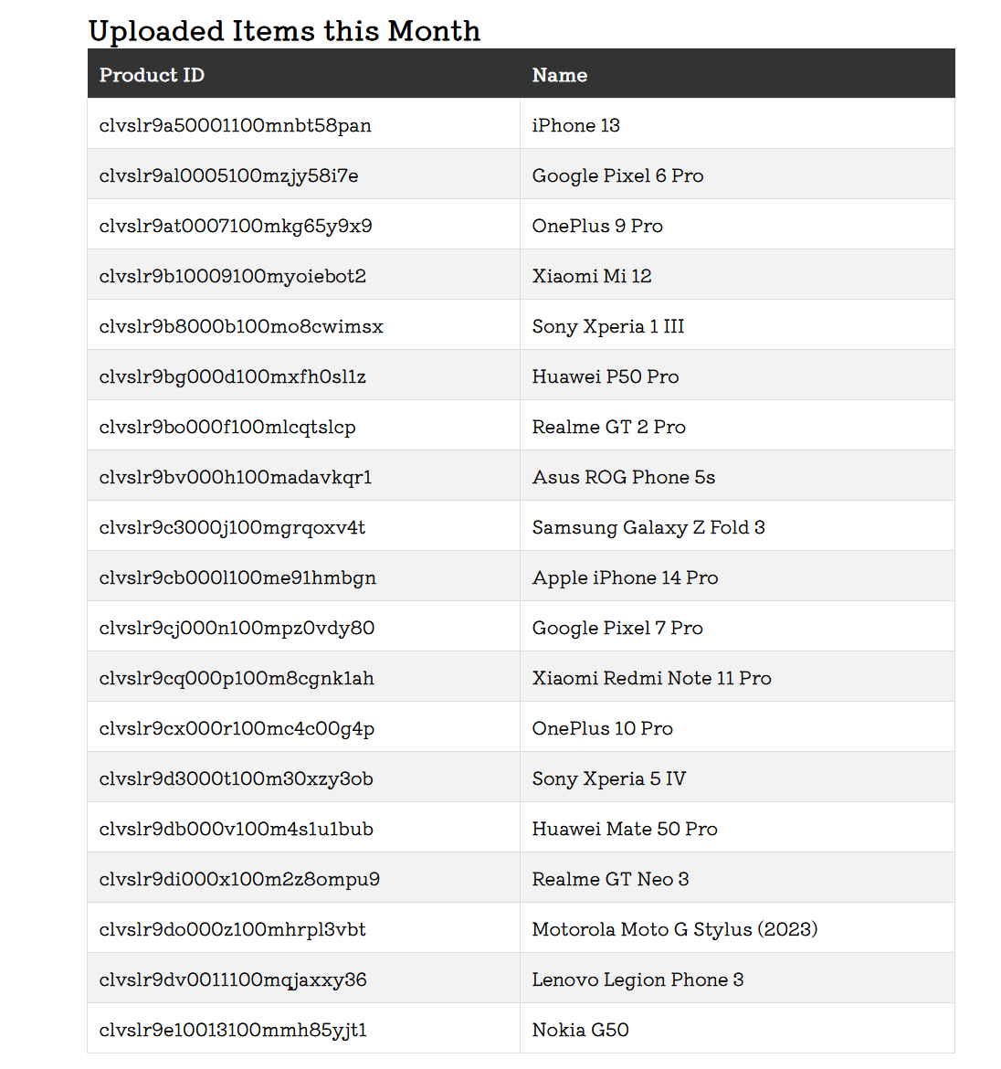**

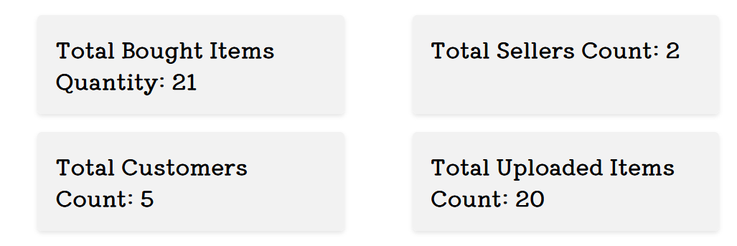

**Contribuitions of each Member**

**Abdullah Abdullah: In this project I made the documentation and report and statistics page and gathering the information and making the site live and video demo  
  
Salman Taher: Did the migrations from localstorage to Prisma and implemented react and file management and backend processes and API**

**Mohammed Albazeli: helped with the report**